**B.TECH. (2020-24)**

**Artificial Intelligence**

**Open Ended**

**LAB File**

on

**Fundamentals of Machine Learning**

**[CSE313]**

Submitted To

**Dr Monika Arora**

Submitted By

|  |  |  |
| --- | --- | --- |
| **Hitesh** | **A023119820027** | **5AI 1** |
| **Gauri Tyagi** | **A023119820028** | **5AI 1** |
| **Kushagra Dubey** | **A023119820029** | **5AI 1** |
| **BHOOMIKA SHARMA** | **A023119820030** | **5AI 1** |
| **SUNIDHI SINGH** | **A023119820032** | **5AI 1** |

DEPARTMENT OF COMPUTER SCIENCE AND ENGINEERING

AMITY SCHOOL OF ENGINEERING AND TECHNOLOGY

AMITY UNIVERSITY UTTAR PRADESH

NOIDA (U.P)

**OPEN ENDED EXPERIMENT**

**Aim**

To implement k means clustering algorithm over a dataset

**Software Used**

Google Colab

**Program Code and Output**

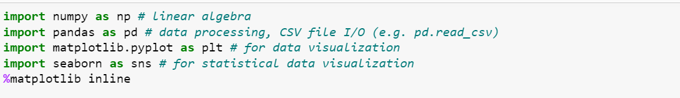

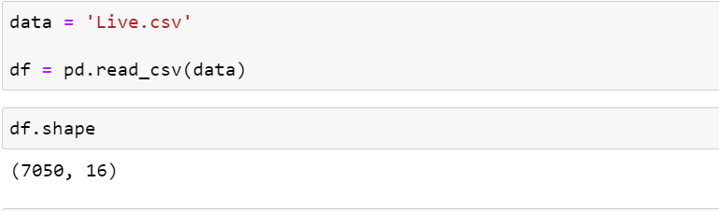

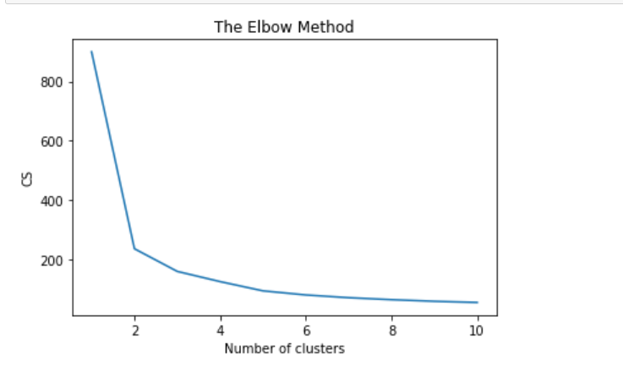

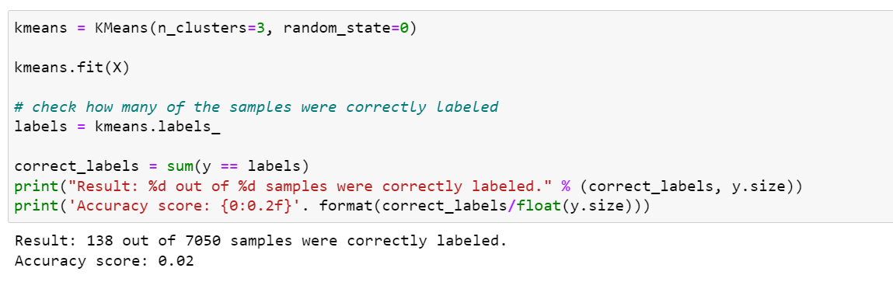

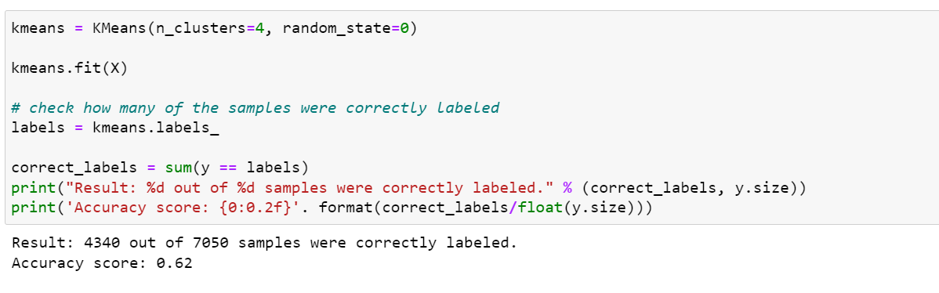

**Discussion and Conclusion**

The lesser the model inertia, the better the model fit. So, we use the Use elbow method to find optimal number of clusters. There is a kink at k=2.Hence k=2 can be considered a good number of the cluster to cluster this data. So, we have changed the value of k and found relatively higher classification accuracy of 62% with k=4. Hence, we can conclude that k=4 being the optimal number of clusters.

